# Assignment 1 Review

The approach taken to develop this assignment was to put a heavy emphasis on views and templating for the front end to clearly assess the controller logic and data algorithms in the back end.

The templates where initially developed in PHP using a mock database of PHP class objects to test the processing and function to display the data that was manipulated in the backend.

Data processing was initially done on the same page as the views. After Laravel was implemented all data checking was done on web.php where the routing is done.

This project was a complete success as all tables where given their own id attributes, they were Vehicle_id, Client_id, Booking_id rather than the registration, licence number and the registration and licence number as foreign keys respectively. However the latter mentioned attributes where places a constraint to be unique in the table definition of the database.

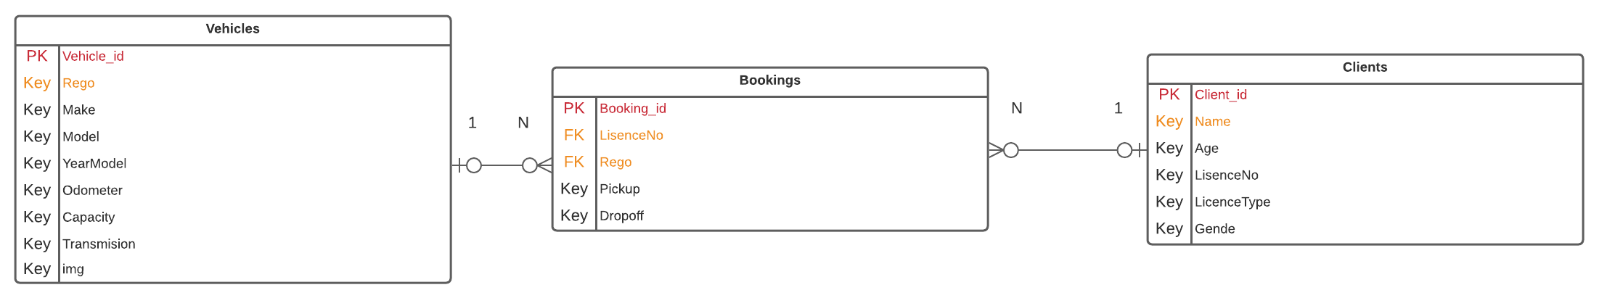

The only shortcomings this code has at this time is the need to employ defensive programming by using more *forelse* loops instead of *foreach* in case the delete function is used on all data entries. I will need to address this in Assignment 2.

To validate booking the process was as follows, the pickup and return dates entered by the user was compared to all the dates for a vehicle with the same registration number by iterating through each booking.

The validation for bookings is as follows:

Case 0: The pickup date is less than the return date.

Case 1: The pickup date and return dates are NOT BOTH greater than the pickup date of another booking and at the same time BOTH are less than the return date of another booking.

Case 2: The entered pick up date is NOT less than the pick up date of another record while at the same time the entered return date is greater than the same record pick up date.

Case 3: The entered pick up date is not less than another records return date and the at the same time the entered return date is after the mentioned records return date.

Case 4: The entered dates have a pickup date that is no later than the day the booking is being made.

All of these are illustrated below.

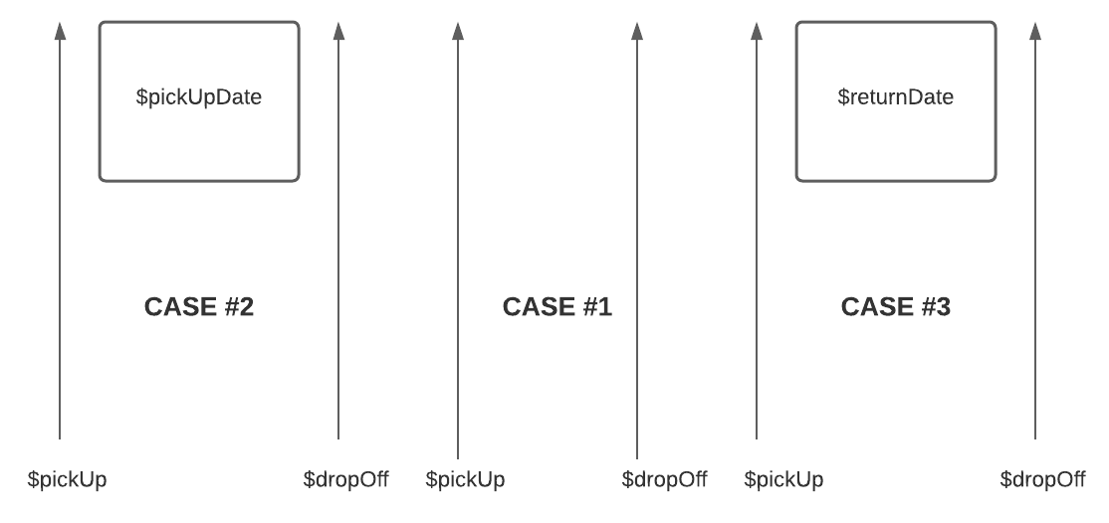

Video Link: <https://web.microsoftstream.com/video/75605ea1-92e6-4e1b-8d40-5d90e0bd9145>